The Coast Guard and the European Green Deal

How does the Green Deal affect the operations of coast guard authorities from different European partners? The Green Deal is a package of policy initiatives launched by the European Commission which aims to make the European Union climate neutral by 2050. How can we make security and law enforcement in European waters as green and sustainable as possible? What opportunities does the Green Deal create for coast guard organisations? And what challenges does this pursuit of sustainability entail?

These questions constituted the theme of the second workshop under the Belgian chairmanship of the ECGFF, the European Coast Guard Functions Forum, which brings together the coast guard authorities of several European countries to work on collaborative issues.
From Monday the 17th till Wednesday the 19th of April, delegations gathered in the Portuguese capital Lisbon, where EMSA is headquartered. The European Maritime Safety Agency was established in 2002 to ensure a high, uniform and effective level of maritime safety, security, prevention of and response to pollution caused by ships.
The workshop kicked-off with a welcome speech by Nathalie Balcaen, Flemish president of the ECGFF. Ms Balcaen emphasized the commitment of the Belgian Coast Guard, which guards one of the shortest stretches of coastline in Europe but is at the same time partly responsible for one of the busiest shipping lanes in the world.
During a first session, information and expertise was mainly exchanged on the new legislation surrounding the Green Deal and on challenges and opportunities for maritime transport, i.e. using alternative energy sources to power ships and better monitoring and control of exhaust fumes.
The topic of marine pollution was also discussed, more specifically prevention activities to protect the environment and the deployment of resources in the event of a pollution incident. 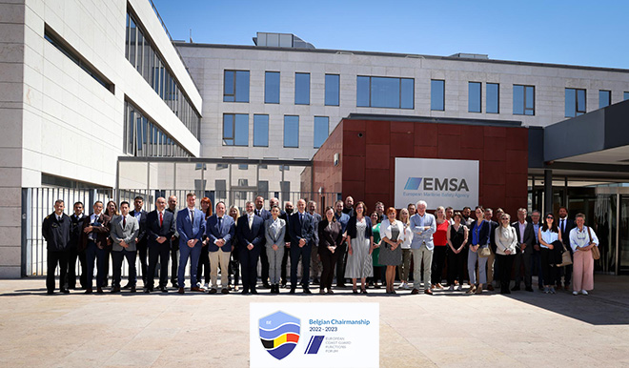
How can the Coast Guard adequately respond to loss of cargo from ships, or fuel tank leaks? And most importantly, how can pollution, of any scope, simply be avoided?
A notable speaker on the first day was Mr. Carl Decaluwé, governor of the Belgian province of West Flanders. The governor is responsible for coordinating emergency response on the North Sea and chairs the Belgian Coast Guard’s consultation body.
The second day was largely dedicated to EMTER 2.0, the European Maritime Transport Environmental Report. The workshop looked ahead to the results of this new study by EMSA and the European Environment Agency (EEA), which will not be published until next year. The report is a follow-up to the first version which was published in 2021 and probes the far-reaching effects that maritime transport has on the environment. For instance, it zooms in on the effects of shipping on climate, air quality, marine fauna and flora and the health of European citizens.
During the closing session, Ms. Maja Markovčić Kostelac, Executive Director of EMSA, commended the Belgian Chairmanship of the ECGFF underlining the excellent cooperation that went into organising what was a highly informative and yet very practical workshop.
The next European workshop will once again take place on the Belgian coast. It starts on May 2nd with the BELCOASTEX exercise, during which various security scenarios will be tested in an offshore wind farm. From 2 to 4 May, EFCA, the European Fisheries Control Agency, will take centre stage. At the end of May, delegations will meet in Brussels to discuss cyber security. Later this year, in September, the final conclusions of the workshops will be formulated during a closing event in Knokke, Belgium. After this, the Belgian presidency will be concluded and the chairmanship of the ECGFF will be passed on to Portugal.

